Email Campaign Effective Analysis

1. Introduction
Email marketing is one of the most widely used digital marketing channels, helping businesses communicate with customers through newsletters, promotions, and event invitations. However, measuring the success of campaigns is often challenging. Metrics such as open rates, click rates, and conversion rates are crucial for evaluating performance, but raw data alone cannot provide actionable insights. This project focuses on designing an interactive Power BI dashboard that analyzes campaign performance across dimensions like campaign type, audience segment, device, and geography. The goal is to help marketers understand which campaigns are most effective, identify engagement patterns, and optimize future campaigns.

2. Problem Statement
Marketers face several challenges in email campaign management:
- Difficulty in comparing performance across different campaign types (newsletters, promotional, events, nurturing).
- Lack of visibility into how different customer segments (leads vs existing customers) respond.
- Uncertainty about the impact of devices, geography, and campaign timing on engagement.
- No consolidated view of key KPIs (open rate, click rate, conversion rate, unsubscribe rate).
The project addresses these challenges by building a Power BI dashboard that consolidates raw email data into intuitive visualizations, enabling better decision-making and campaign optimization.

3. Dataset Description
The dataset used for this project contains 10,000 email records from multiple campaigns. Each record represents a campaign email sent to an individual recipient. Dataset include Campaign details like Campaign Name, Campaign Type, Conversion Target also Date Sent Audience details like Client Email, Client Segment, Country and Engagement flags: Opened, Clicked, Bounced, Unsubscribed, Conversion- Technical info: Device, Country Latitude, Country Longitude
This structure allows analysis of both overall campaign performance and detailed breakdowns by segment, geography, and channel.

4. Tools Used
- Microsoft Excel → for initial inspection of raw data.
- Power BI Desktop → for cleaning (Power Query), building the data model, creating DAX measures, and designing dashboards.

5. Methodology

Data Preparation - Data was cleaned and standardized to ensure accuracy and consistency.

Removed duplicate rows.

Standardized categorical fields (e.g., “mobile” → “Mobile”).

Replaced missing values (e.g., Device → “Unknown”).

Derived helper columns (DeliveredFlag, SendDate).

Data Modelling
- Implemented a star schema with EmailData as the fact table.
- Added a Date table to support time-based analysis.
- Created DAX measures for key KPIs (Delivered, Opens, Clicks, Conversions, Unsubscribes, Rates).

- Dashboard Design - The dashboard was designed in two pages for clarity:
Page 1 (Overview Dashboard):
- KPIs:Open Rate, Click Rate, Conversion Rate, Unsubscribe Rate, Bounce Rate.
- Click Rate by Segment: Donut chart comparing customers vs leads.
- Click Rate by Conversion Target: Bar chart showing effectiveness of targets like Web Visit, Purchase, Sign-Up.
- Click Rate by Campaign Type: Donut chart showing engagement across campaign categories.
- Performance Table: Summary of campaign type vs impressions, conversions, and rates.
Page 2 (Performance Dashboard):
- Click Rate by Campaign Name: Bar chart ranking campaigns by performance.
- Click & Conversion Rate by Campaign Type: Combo chart with Click Rate (columns) and Conversion Rate (line).
- Click Rate by Country: Pie chart highlighting geographical differences.
- Filters: Campaign Name, Campaign Type, Date Sent slicers for drill-down.

6. Outputs: Dashboards

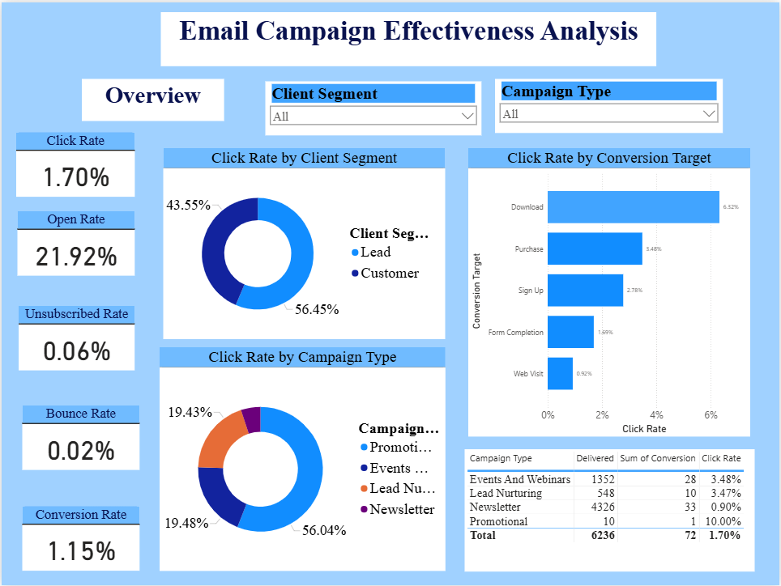

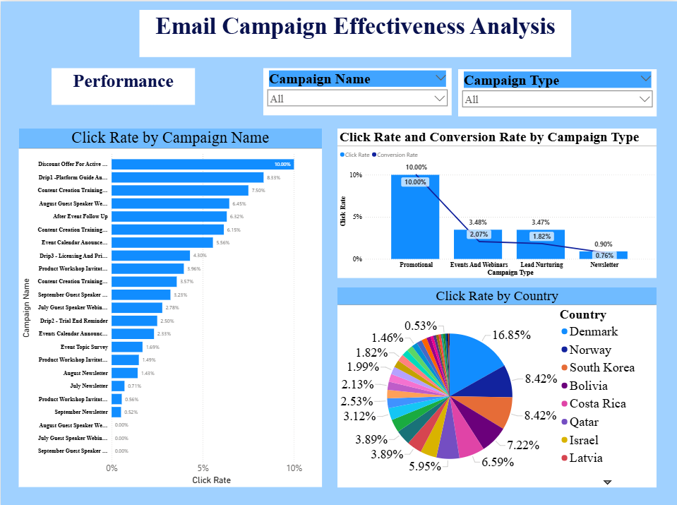

7. Conclusion

This project proved that Power BI can turn raw email campaign data into actionable insights. The project highlights the business value of using Power BI for marketing analytics. It transformed 10,000 rows of campaign data into a user-friendly dashboard that tracks KPIs in real time. By analysing open rates, click rates, and conversions across campaign types, customer segments, and countries, the dashboards help marketers quickly identify which campaigns perform best and which need improvement. The ability to filter and drill down provides flexibility, making it a valuable tool for planning future campaigns.

